INSTRUCTIONS TO USE CLASSROOM EXCEL SHEETS TO DO ASSIGNED SEATING in a single classroom

Step 1 Download current roster from course in Blackboard. Go to Grade Center. Then click using “Work Offline” option. Choose “Download” and “User Information Only” and “Tab” as delimiter type. Click “Submit”, then click “Download” button. Save and open the XLS file.
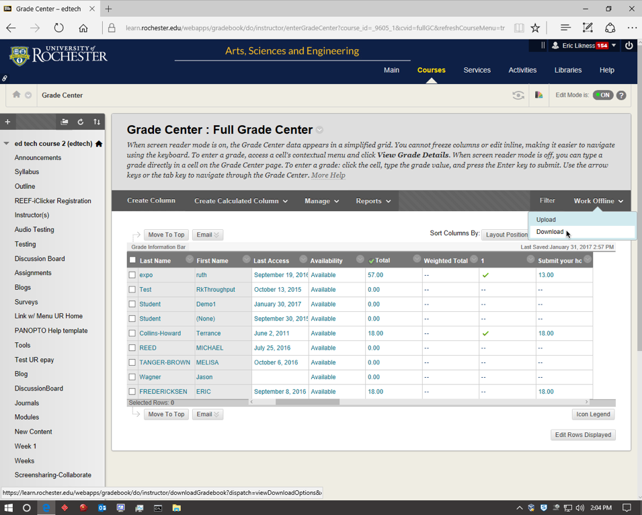

Step 2 In that downloaded file, create new column at the end entitled, "EXAMNAME_Seat" (e.g., MT1, MT2, Final)
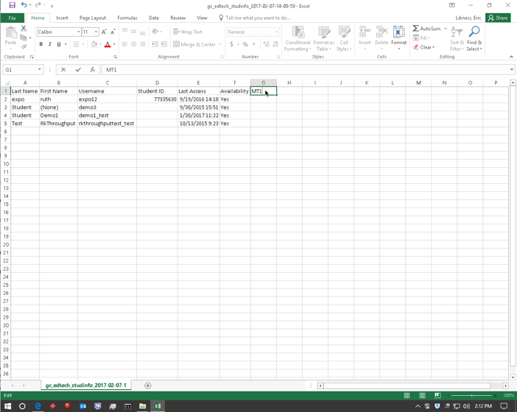
Step 3 Select and save the excel sheet for your classroom available at http://www.rochester.edu/college/itresources/classrooms/single-room/assigned-seats.html
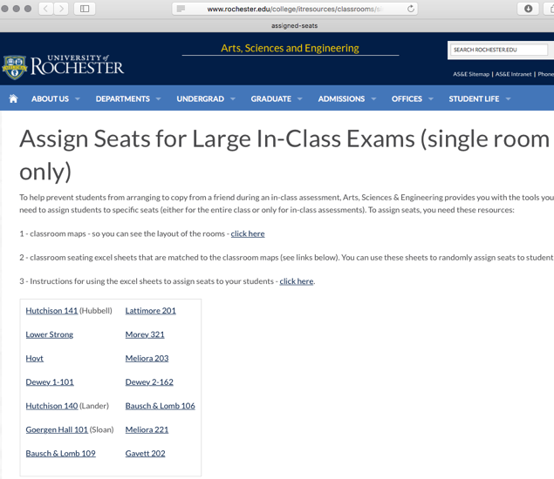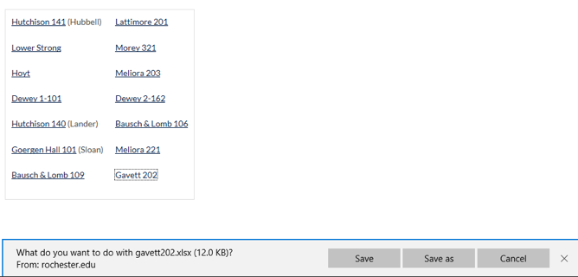

Step 4 Open the spreadsheet. Copy the unique_seat_# (column c) numbers from the classroom excel sheet and paste, using "Paste Special" and click "Values" or ”Text”, into your class roster in the column named “EXAMNAME_Seat”
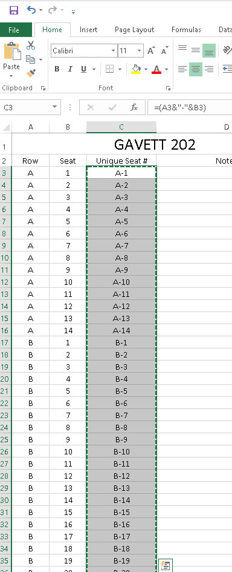
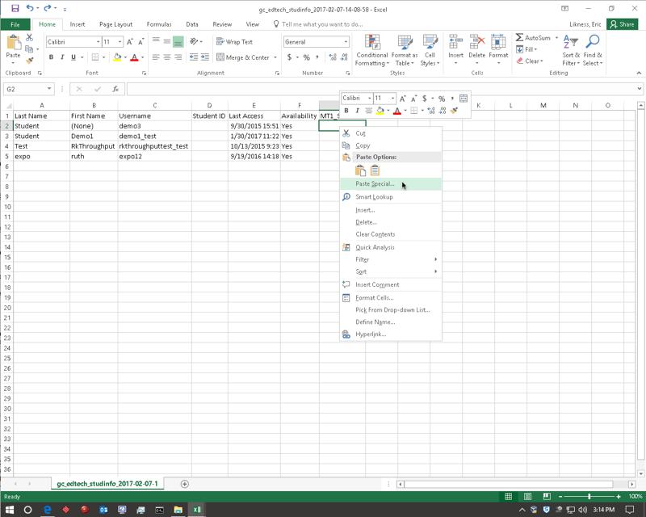

Step 5 Delete any seats you want to intentionally leave empty, e.g. first row, every other seat
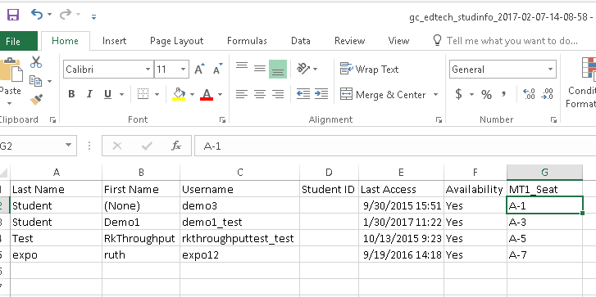

Now you have a file with seat numbers and student names, but to randomize the seats, there are more steps required:

Step 6 In the column next to EXAMNAME_Seat, title the column "Random"

Step 7 In that Random column, type =RAND() in the first cell in order to generate a random number between 0 and 1. (NOTE: This number seems to regenerate each time you perform any action in Excel-- don't be concerned.)
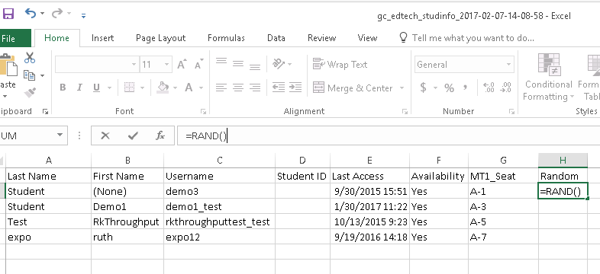

Step 8 Copy the formula in each cell of the entire column.
(NOTE: Click the green square on the lower “right” corner of the selected cell and drag DOWN the column, that fills each cell with =RAND)
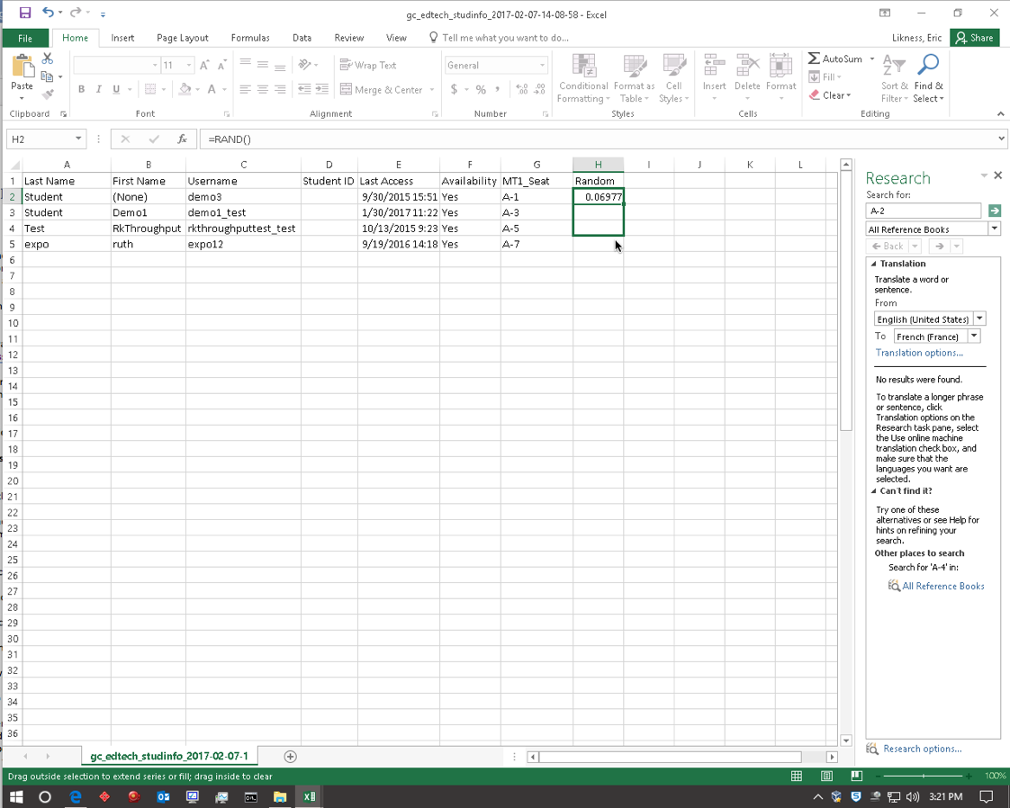

Step 9 Select ONLY the two columns "Random" and “EXAMNAME_Seat"
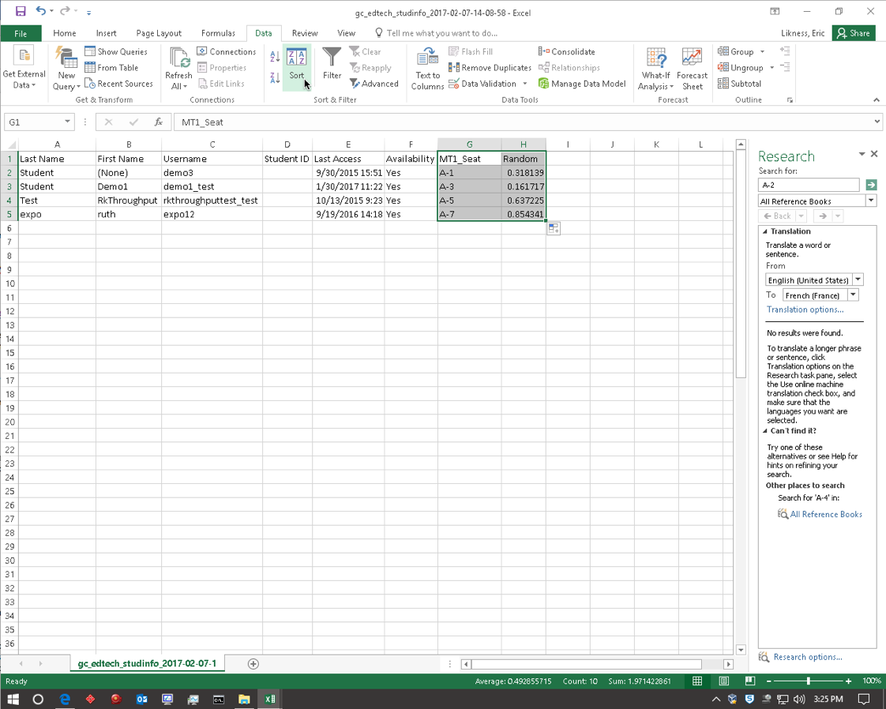
Step 10 Go to "Data" in the Excel Toolbar/Upper menu, select "Sort". If you are using Excel 2010 go to the end of this set of directions to follow the Steps for Excel 2010

Step 11 In the pop-up window that appears, click on "Header Row" to indicate your list has one.

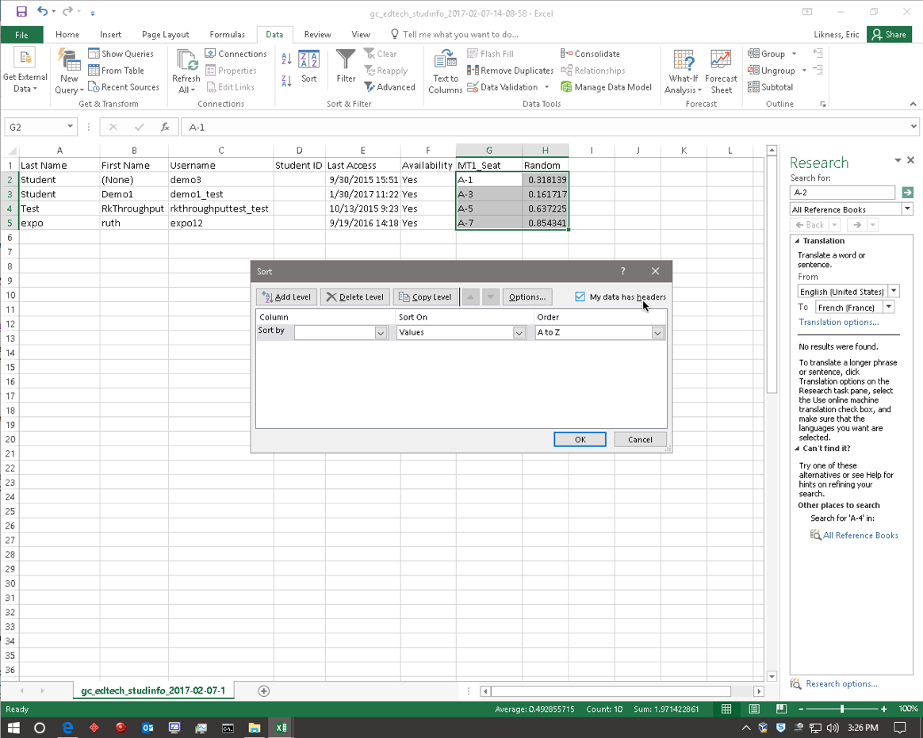

Step 12 Go to "Sort by" in the same pop-up window, and select "Random".
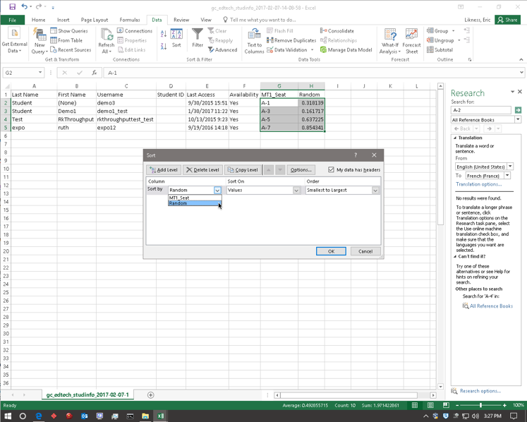
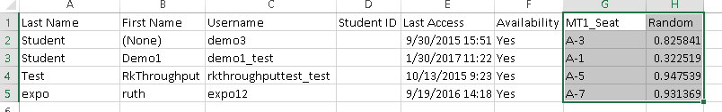

Now you have a random seat in the classroom assigned to every student but you have one final step:

Step 13 Now you can re-upload the file to Grade Center on Blackboard using "Work Offline" option. You might want to delete the "Random" column before or after uploading the file so students don't worry about it. Blackboard can be fussy with file types, but if you save as a “.csv” (Comma Separated Values) from Excel everything should work.
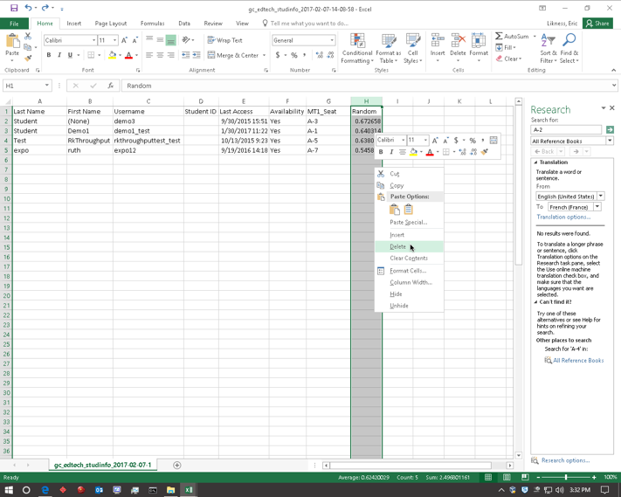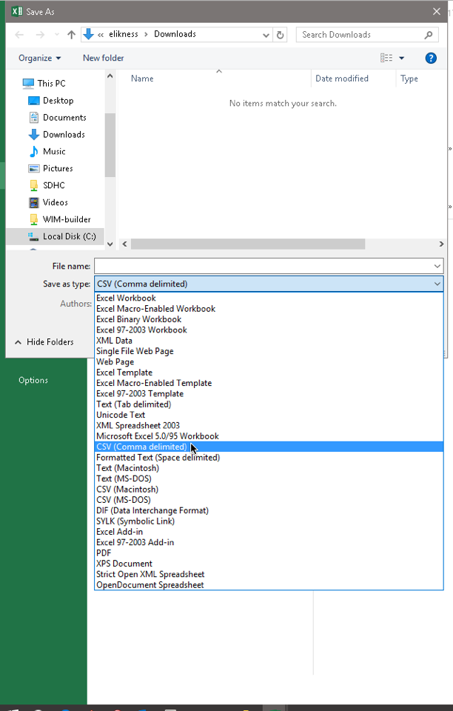

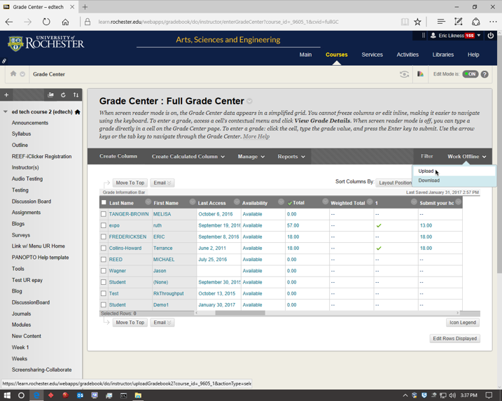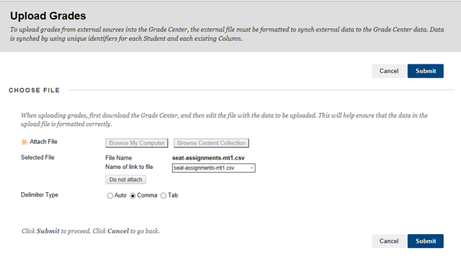

Steps for Excel 2010 on Windows
You may get an error message like this one:

1. Instead of selecting and sorting, …
2. Leave everything selected->Copy the two columns
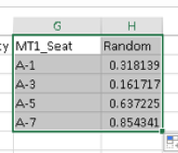
3. Paste into a blank worksheet
4. Leave the columns highlighted after the paste->Then sort on Random column
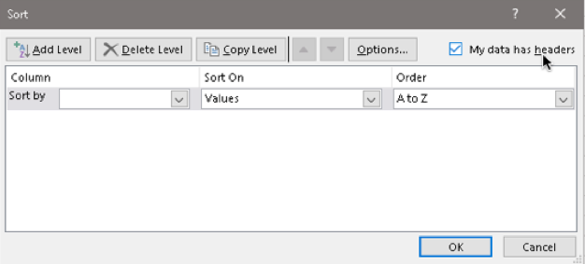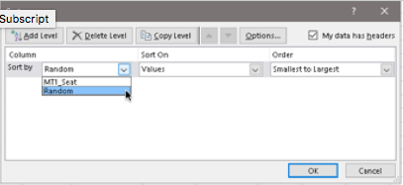
6. Select just the EXAMNAME_Seat column and paste back into the first worksheet, choosing the column with the Exam name in the header.
